ASSIGNMENT – 4

Date | 22nd October 2022
Name | S.V.Subushri
Project name | Gas Leakage Monitoring and Alerting System
Maximum marks | 2 marks

#include <WiFi.h>
#include <PubSubClient.h>
void callback(char* subscribetopic,byte* payload, unsigned int payloadLength);
#define ORG "ltsj9j"
#define DEVICE_TYPE "IOT"
#define DEVICE_ID "1234"
#define TOKEN "12345678"
String data3;

char server[]= ORG ".messaging.internetofthings.ibmcloud.com";
char publishTopic[]="iot-2/evt/distance/fmt/json";
char subscribeTopic[]="iot-2/cmd/test/fmt/String";
char authMethod[]="use-token-auth";
char token[]=TOKEN;
char clientID[]="d:"ORG":"DEVICE_TYPE":"DEVICE_ID;

WiFiClient wifiClient;
PubSubClient client(server,1883,callback,wifiClient);

#define ECHO_PIN 2
#define TRIG_PIN 4
#define led 5

void setup() {
// put your setup code here, to run once:
Serial.begin(115200);
pinMode(led, OUTPUT);
pinMode(TRIG_PIN, OUTPUT);
pinMode(ECHO_PIN, INPUT);
wificonnect();
mqttconnect();
}
float readDistanceCM() {
digitalWrite(TRIG_PIN, LOW);
delayMicroseconds(2);
digitalWrite(TRIG_PIN, HIGH);
delayMicroseconds(10);
digitalWrite(TRIG_PIN, LOW);
int duration=random(1,200);
//Serial.println(duration);
//duration = pulseIn(ECHO_PIN, HIGH);
return duration ;
//Serial.println(duration);

}

void loop() {
float distance = readDistanceCM();
//Serial.println(distance);

bool isNearby = distance < 100;
digitalWrite(led, isNearby);

Serial.print("Measured distance: ");
Serial.println(distance);
if(distance<100){
PublishData2(distance);

}else{
PublishData1(distance);

}
//PublishData(distance);
delay(1000);
if(!client.loop()){
mqttconnect();
}

//delay(2000);
}
void PublishData1(float dist){
mqttconnect();
String payload= "{\"distance\":";
payload += dist;
payload+="}";

Serial.print("Sending payload:");
Serial.println(payload);

if(client.publish(publishTopic,(char*)payload.c_str())){
Serial.println("publish ok");
} else{
Serial.println("publish failed");
}
}
void PublishData2(float dist){
mqttconnect();
String payload= "{\"ALERT\":";
payload += dist;
payload+="}";

Serial.print("Sending payload:");
Serial.println(payload);

if(client.publish(publishTopic,(char*)payload.c_str())){
Serial.println("publish ok");
} else{
Serial.println("publish failed");
}
}
void mqttconnect(){
if(!client.connected()){
Serial.print("Reconnecting to ");
Serial.println(server);
while(!!!client.connect(clientID, authMethod, token)){
Serial.print(".");
delay(500);
}
initManagedDevice();
Serial.println();
}
}

void wificonnect(){
Serial.println();
Serial.print("Connecting to");

WiFi.begin("Wokwi-GUEST","",6);
while(WiFi.status()!=WL_CONNECTED){
delay(500);
Serial.print(".");
}
Serial.println("");
Serial.println("WIFI CONNECTED");
Serial.println("IP address:");
Serial.println(WiFi.localIP());
}

void initManagedDevice(){
if(client.subscribe(subscribeTopic)){
Serial.println((subscribeTopic));
Serial.println("subscribe to cmd ok");
}else{
Serial.println("subscribe to cmd failed");
}
}

void callback(char* subscribeTopic, byte* payload, unsigned int payloadLength){
Serial.print("callback invoked for topic:");
Serial.println(subscribeTopic);
for(int i=0; i<payloadLength; i++){
data3 += (char)payload[i];
}
Serial.println("data:"+ data3);
if(data3=="lighton"){
Serial.println(data3);
digitalWrite(led,HIGH);
}else{
Serial.println(data3);
digitalWrite(led,LOW);
}
data3="";
}

Wokwi project link:
https://wokwi.com/projects/347241332717126227

Alert case:

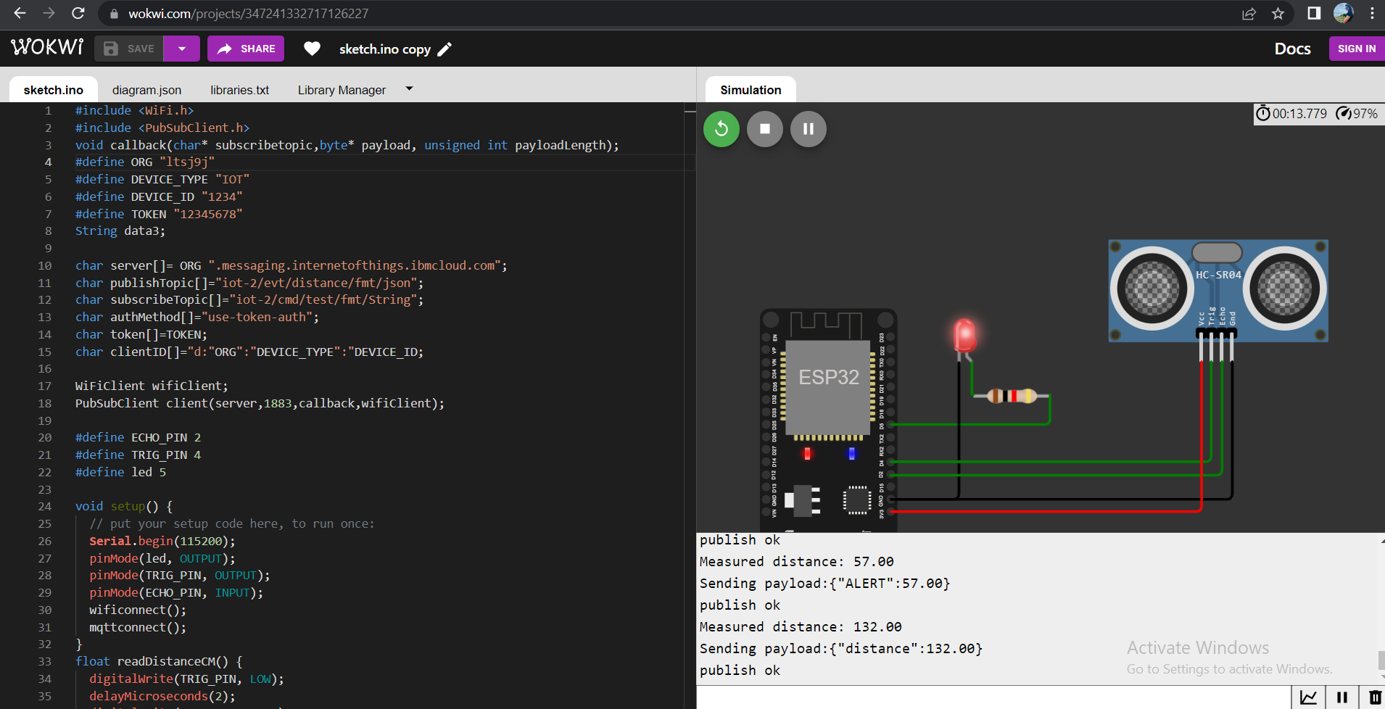

Normal case:

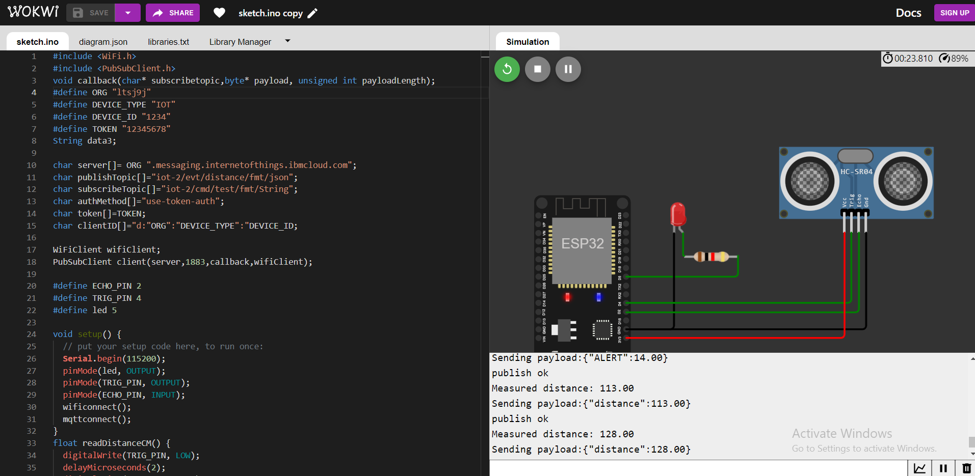

Cloud storage:

